Database schema
In this chapter the database schema is shown next, after this, all the components of the diagram, like tables, are going to be explained:
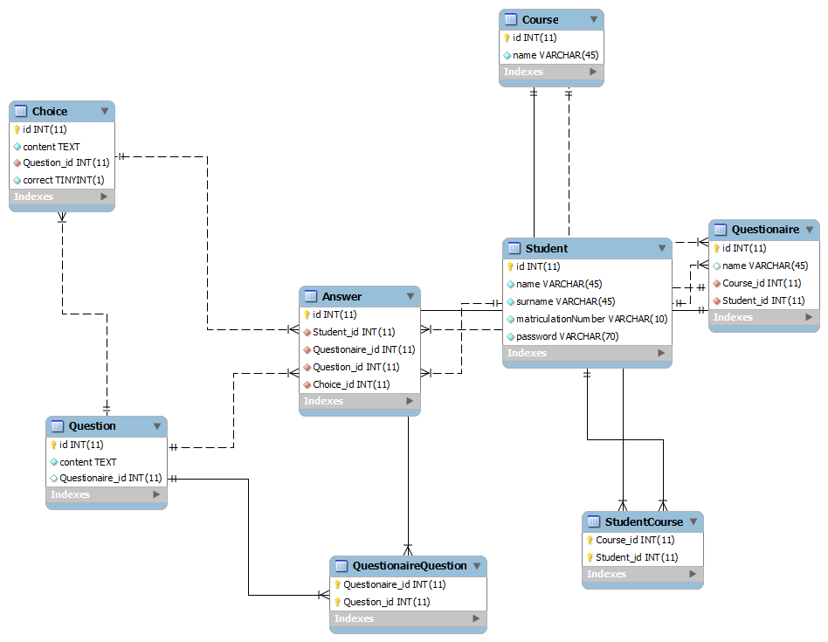

Tables
In the previous diagram some tables can be seen:
- Choice: This datatable save all the possible answers for a question.
- Question: In this table all questions created by the students for questionnaires are stored.
- Answer: This table store all the answers of the students in every questionnaire.
- Course: In this table is stored all the information about the course in which the students can be added
- Student: It contains all the information of the students registered in the system
- Questionnaire: Is all the information about the questionnaires created by the students
- QuestionaireQuestion and StudentCourse: Are tables created because of m-n relations

